

**Capstone Project Report**

**Report 2 – Project Management Plan**

– Hanoi, August 2019 –

**Table of Contents**

I. Project Report 3

1. Status Report 3

2. Team Involvements 3

3. Issues/Suggestions 3

II. Project Management Plan 4

1. Overview 4

1.1 WBS & Estimation 4

1.2 Project Objectives 4

1.3 Project Risks 4

2. Management Approach 5

2.1 Project Process 5

2.2 Quality Management 5

2.3 Training Plan 5

3. Master Schedule 5

4. Project Organization 6

4.1 Team & Structures 6

4.2 Roles & Responsibilities 6

5. Project Communication 6

5.1 Communication Plan 6

5.2 External Interface 7

6. Configuration Management 7

6.1 Tools & Infrastructures 7

6.2 Document Management 8

6.3 Source Code Management 8

# I. Project Report

## 1. Status Report

|  |  |  |  |
| --- | --- | --- | --- |
| **#** | **Work Item** | **Status** | **Notes (Work Item in Details)** |
| 1 |  | Pending |  |
| 2 |  | In Progress |  |
| 3 |  | Completed |  |

## 2. Team Involvements

|  |  |  |  |
| --- | --- | --- | --- |
| **#** | **Task** | **Member** | **Notes (Task Details, etc.)** |
| 1 |  | KienNT |  |
| 2 |  | TuanTV |  |
| 3 |  | AnhLM |  |

## 3. Issues/Suggestions

|  |  |  |  |
| --- | --- | --- | --- |
| **#** | **Issue** | **Status** | **Notes (Solution, Suggestion, etc.)** |
| 1 |  | Pending |  |
| 2 |  | In Progress |  |
| 3 |  | Completed |  |

# II. Project Management Plan

## 1. Overview

### 1.1 WBS & Estimation

*[Create/Provide the project WBS & Estimation following the table template as below. In which, we categorize the WBS items into three levels of complexity (Simple, Medium, Complex) and estimate the total effort to complete each item in man-day]*

|  |  |  |  |
| --- | --- | --- | --- |
| **#** | **WBS Item** | **Complexity** | **Est. Effort** |
| ***1*** | ***Feature 1*** |  |  |
| 1.1 | WBS item 1.1 | Simple | 4 |
| 1.2 | WBS item 1.2 | Medium | 7 |
| 1.3 | WBS item 1.N | Complex | 10 |
| ***2*** | ***Feature 2*** |  |  |
| ***2.1*** | ***…*** |  |  |
| ***Total Estimated Effort (man-days)*** | | | ***21*** |

### 1.2 Project Objectives

*[Provide the overall project objective description and then the specific target metrics of your project in term of time, cost, and quality. For example*

* *Timeliness (%):*
* *Allocated Effort (man-days):*
* *Defect Distribution:*

|  |  |  |  |  |
| --- | --- | --- | --- | --- |
| **#** | **Quality Stage** | **No. of Defects** | **% of Defect** | **Notes** |
| 1 | Reviewing |  |  |  |
| 2 | Unit Test |  |  |  |
| 3 | Integration Test |  |  |  |
| 4 | System Test |  |  |  |
| 5 | User Acceptance Test |  |  |  |
| ***Total*** | | ***Xxx*** | ***100%*** |  |

]

### 1.3 Project Risks

*[List out the details on project risks in the table below]*

|  |  |  |  |  |
| --- | --- | --- | --- | --- |
| **#** | **Risk Description** | **Impact** | **Possibility** | **Response Plans** |
| 1 |  |  |  |  |

## 2. Management Approach

*[Describe the approach you would use the manage and implement your project]*

### 2.1 Project Process

**2.1.1 Agile Model Development Methodology:**

**-** With this model, the product will be brought to the customer soon and received feedback from the customer then the product will be easily modified according to the customer's comments. From there, the product will become more and more perfect. Moreover, this model also helps to better control the progress and status of the project, especially tracking the progress of team work.

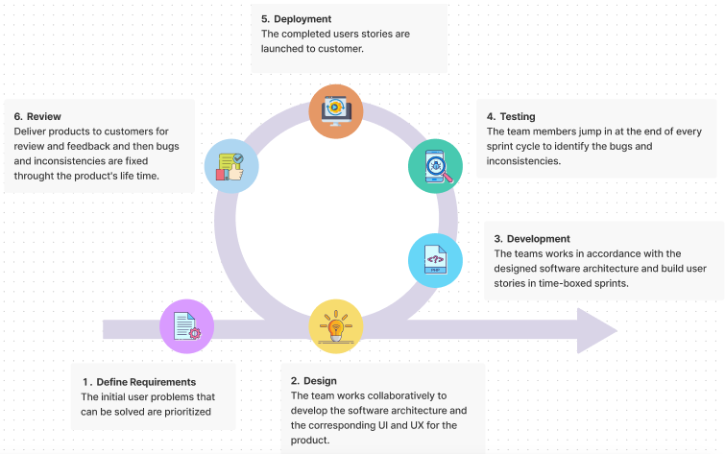

**2.1.2 Summary Diagram**: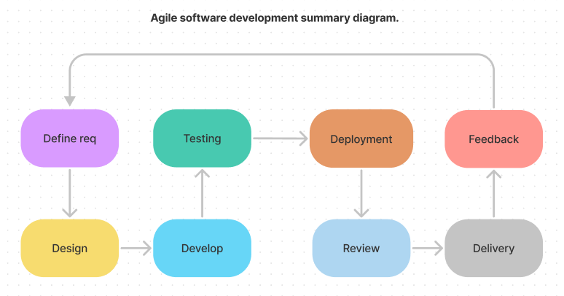

### 2.2 Quality Management

* *Quality Built-in Concept*
* *Fast Delivery*
* *Shift-left Test*
* *Shift-right Test*
* *Test Strategy Collection*
* *Test Method Collection*

### 2.3 Training Plan

*[You need to plan the training activities in case any of your team member lack of knowledge/skills to handle the project works]*

|  |  |  |  |
| --- | --- | --- | --- |
| Training Area | Participants | When, Duration | Waiver Criteria |
| Java Spring Boot |  |  | Mandatory |
| Angular |  |  | Mandatory |
| Git, Github |  |  | Mandatory |

## 3. Master Schedule

*[Given the main project deliverables. Those can be internal and/or external deliverables. Students can prepare master schedule like the table format as below or in the more detailed structure as in the attached sample file -* ***Report2_Sample High Level Project Schedule.pdf****]*

|  |  |  |  |  |
| --- | --- | --- | --- | --- |
| **#** | **Deliverable** | **Effort** | **Due Date** | **Deliverable Scope** |
| 1 | Project Plan |  |  |  |
| 2 | SRS |  |  |  |
| 3 | Design |  |  | Architecture Design, Detailed Design, Database |
| 4 | Code Package1 |  |  | Code & Unit test, System test cases |
| 5 | Code Package2 |  |  | Code & Unit test, System test cases |
| 6 | Code PackageN |  |  | Code & Unit test, System test cases |
| 7 | UAT Package |  |  | Codes, System test reports |
| 8 | Final Package |  |  | Final Codes & documents, User manual |

## 4. Project Organization

### 4.1 Team & Structures

*[See sample below]*

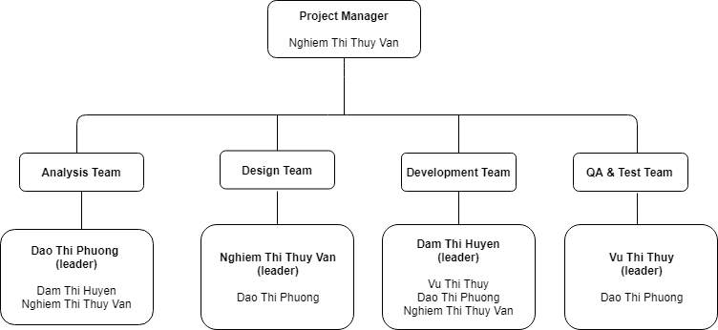

### 4.2 Roles & Responsibilities

*[Describe the roles & responsibilities in your project, in the format as the sample below]*

|  |  |
| --- | --- |
| **Role** | **Responsibility** |
| Project Manager |  |
| Analysis Leader |  |
| Analysis Member |  |
| Design Leader |  |
| Design Member |  |
| Technical Leader |  |
| Test Leader |  |
| Test Member |  |

## 5. Project Communication

### 5.1 Communication Plan

|  |  |  |  |  |
| --- | --- | --- | --- | --- |
| **Communication Item** | **Who/ Target** | **Purpose** | **When, Frequency** | **Type, Tool, Method(s)** |
|  |  |  |  |  |
|  |  |  |  |  |

### 5.2 External Interface

#### a. FU Contacts

|  |  |  |  |
| --- | --- | --- | --- |
| Function | Contact Person  (name, position) | Contact address  (email, telephone) | Responsibility |
| Supervisor | Nguyen Trung Kien | kiennt@gmail.com  0912656836 | - Provide document template - Give instruction to project team - Review deliverables - Supervise project status |
| Supporter | Nguyen Thi Mai Phuong | Phuongntm5@fe.edu.vn | - Provide document template  - Receive report project  - Answer questions about the project |

#### b. Customer Contacts

|  |  |  |  |
| --- | --- | --- | --- |
| Function | Contact Person  (name, position) | Contact address  (email, telephone) | Responsibility |
| Supervisor | Nguyen Trung Kien | kiennt@gmail.com  0912656836 | - Provide document template - Give instruction to project team - Review deliverables - Supervise project status |
| Supporter | Nguyen Thi Mai Phuong | Phuongntm5@fe.edu.vn | - Provide document template  - Receive report project  - Answer questions about the project |

## 6. Configuration Management

### 6.1 Tools & Infrastructures

|  |  |
| --- | --- |
| **Programming languages** | Java, Angular 7 |
| **Framework** | Java Spring Boot |
| **API** | API |
| **DBMS** | My SQL |
| **IDEs/Editors** | Visual Studio Code, Eclipse |
| **UML tools** | Visio, Astah |
| **Version Control** | Git hub |
| **Deployment server** | Amazon Web Service |
| **Project management tool** | Microsoft Project |

### 6.2 Document Management

*[Describe how you would manage project documents & their changes/versions]*

### 6.3 Source Code Management

*[Describe how you would manage project source codes & their changes/versions]*